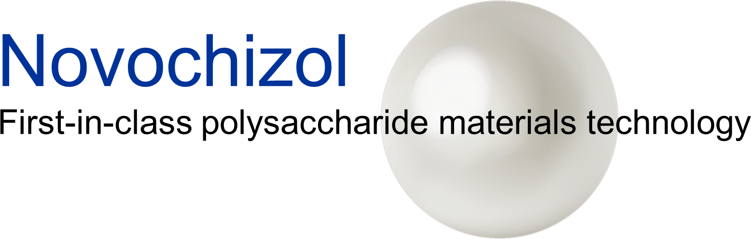

MATERIAL TRANSFER AGREEMENT (MTA)

This agreement (hereinafter “Agreement”) is made by and between:

Novochizol SA, a Swiss Public Limited Company with a registered capital of 100 000 CHF, having a place of business at Route de l’Ile-au-Bois 1A, 1870 Monthey VS SUISSE, registered at the Trade and Companies Register of the Bas-Valais under the number CHE-319.073.356 and duly represented by Abert Yvan Loroch, Chief Executive Officer,
Hereinafter referred to as the “Provider”,
And
[ Please provide all necessary counterpart information]
Hereinafter referred to as the “Recipient”,

The Provider and the Recipient are hereafter collectively referred as the "Parties" and separately as a “Party”.
This Agreement is effective as of the [please insert date] hereinafter “Effective date”

RECITALS
WHEREAS:

A. The Provider owns and is the proprietor of the Intellectual Property Rights and Know How of the chitosan derivative NOVOCHIZOL™ (“Novochizol”), its manufacturing and uses thereof in conjunction with other technologies.

B. The Provider is researching, developing, marketing and commercializing industrial applications of Novochizol in the fields of medicine, agriculture, food industry, life sciences and material sciences.

C. The Recipient [ Please describe relevant ownership, know-how and activities ]

D. The Recipient is interested in evaluating a sample of either Novochizol alone (“Novochizol Sample”) or Novochizol in combination with other specific substances (“Novochizol Products”) as agreed between the Parties and specifically described in Schedule A (the “Purpose”). Novochizol Products may be produced by either Party using substances /materials provided by either Party, solely for the purpose(s) agreed between the Parties and specifically stated in Schedule A The experiments and/or testing required to be conducted for this Purpose are also set out in Schedule A and or any further experiments that may be agreed between the Parties, in writing, in order to further research the Purpose, which will be set out by an additional agreement (the “Addendum”) to this Agreement;

OPERATIVE PROVISIONS

NOW, THEREFORE, in view of the foregoing Recitals which are true and correct and are incorporated by this reference as a material part of this MTA, and in consideration of the terms and conditions set forth below, the Parties agree as follows:
1. MATERIAL TRANSFER
  - The Provider agrees to transfer at no cost to the Recipient the Novochizol Sample or Novochizol Products described in Schedule A.
2. GRANT OF LICENSE/AUTHORITY TO CARRY OUT EXPERIMENTS

2.1 Novochizol is protected by trademarks and under pending patent protection in the name of the Provider and the Novochizol Sample is made available to the Recipient subject to the terms and conditions of this Agreement (i) to use the Novochizol Products in accordance with the Information solely and strictly for the purpose of carrying out the Experiments and evaluating the results of the Experiments internally for the Purpose within the Term (the “Novochizol Testing License”). It is expressly agreed and understood that the Novochizol Testing License does not constitute an implied or express license to use Novochizol generally and any use other than to carry out the Experiments for the Purpose within the Term, is explicitly forbidden.
2.2 The Provider hereby grants to Partner the Novochizol Testing License which is non-exclusive, non-transferable limited testing license of the Novochizol Products (without the right to sublicense).
2.3 The Recipient hereby acknowledges that it shall receive the Novochizol Products, Know How, and Information for the specific purpose of carrying out the Experiments for the Purpose and is prohibited from using the Novochizol Samples for any other purpose. It is expressly agreed and understood that the Novochizol Testing License does not constitute an implied or express license to use Novochizol generally nor does it imply any broader collaboration other that which is specifically agreed herein.
3. RESTRICTIONS ON GRANT
3.1. Except as otherwise specifically permitted in this Agreement, the Recipient may not: modify or create any derivative works of Novochizol unless specifically permitted under the Experiments and Purpose of this Agreement, copy Novochizol, reverse engineer, decompile, or disassemble or otherwise attempt to derive the source for Novochizol or publish or make public any results of the Experiments without the prior written consent and authority of the Provider.

3.2. The Recipient shall not be entitled to file any patent or patent application on results obtained with the Novochizol Products. No party shall use these results without prior written consent of the other party.

3.3. Except as provided in this Agreement, no express or implied licenses or other rights are provided to the Recipient under any patents, patent applications, trade secrets or other proprietary rights or exploitation rights of the Provider, including any Novochizol products made by the Provider. In particular, no express or implied licenses or other rights are provided to use Novochizol products for any commercial purposes such as but not limited to: screening, production, sale, or use in research or consulting for a third party or the filing of a patent application.
3.4. The Recipient agrees not to use the Novochizol products on humans, for profit-making or commercial purposes such as but not limited to: screening, production, sale, or use in research or consulting for a third party or the filing of a patent application.

4. CONFIDENTIALITY & CONFIDENTIAL CONTENT

4.1 The Recipient agrees that, unless otherwise specifically provided herein, the Novochizol Samples, Know How and any Information and or Background which shall be provided to the Recipient by the Provider constitutes proprietary Confidential Information of the Provider.

4.2 Any Confidential Information, Know How, and Background (collectively the “Confidential Content”) provided by either Party to the other, may not disclosed to any third for a period of five (5) years from the time, the receiving Party accessed the aforementioned. This restriction will not apply to any information that is or becomes publicly available without a breach of this restriction; was lawfully known to the receiver of the information without an obligation to keep it confidential; is received from another source that can disclose it is lawfully and without an obligation to keep it confidential; or is independently developed. Either Party may disclose any Confidential Content if required to comply with a court order or other government demand that has the force of law. Before doing so, such Party must seek the highest level of protection available and, when possible, give the other Party enough prior notice to provide a reasonable chance to seek a protective order.

4.3 Each Party agrees not to disclose or allow access to any of the Confidential Content that it will receive from the other Party, to any party other than the employees/agents engaged for the purpose of performing the Experiments for the Purpose within the Term and shall procure that its authorized employees and/or agents shall not disclose to any third party nor use for any purpose except as expressly permitted by this Agreement.

4.4 The obligation to protect Confidential Information under this clause survives the termination of this Agreement and continues indefinitely or until the Confidential Information no longer meets the requirements of being Confidential Information under this Agreement.

4.5 Neither Party will publicize any of the Results and/or use the other’s Party’s name or the other Party’s logo in any press release, publication, product advertising, or for any other promotional purpose, without first obtaining the other Party’s written consent.

5. PROVIDER DISCLAIMER AND LIMIT OF LIABILITY

5.1 The effect of Novochizol contained in the Novochizol Sample with other substances, and/or material is still in testing phase. Novochizol contained in the Novochizol Sample is provided on an “as is” and “as available” basis. The Provider expressly disclaims any and all other warranties of any kind, whether express or implied, including, without limitation, any implied warranties of merchantability, suitability, usability or fitness for a particular purpose, merchantable quality, title or non-infringement of third-party rights, to the extent authorized by law.

5.2 The Recipient assumes its own responsibility for carrying out the Experiments and does so at its own risk.

5.3 In no event will the Provider be liable to the Recipient or any of its employees/agents or any party for – without limitation – any loss of use; interruption of business; or any direct; indirect; special; incidental; exemplary or punitive or consequential damages of any kind (including lost profits) regardless of the form of action whether in contract; tort (including negligence);strict product liability or otherwise; arising out of the use/manipulation of the Novochizol Sample.

6. ENTIRE AGREEMENT

6.1. This Agreement constitutes the entire agreement between the Parties relating to its subject matter. Each Party acknowledges that it has not entered into this Agreement on the basis of any warranty, representation, statement, agreement or undertaking except those expressly set out in this Agreement. Each Party waives any claim for breach of this Agreement, or any right to rescind this Agreement in respect of any representation which is not an express provision of this Agreement. However, this clause does not exclude any liability which either Party may have to the other (or any right which either Party may have to rescind this Agreement) in respect of any fraudulent misrepresentation or fraudulent concealment before the signing of this Agreement.

7. GOVERNING LAW AND JURISDICTION

7.1. This Agreement and any dispute or claim (including non-contractual disputes or claims) arising out of or in connection with it or its subject matter or formation are governed by, and this Agreement is to be construed in accordance with the laws of Switzerland. The Courts of the Canton of Valais, Switzerland will have exclusive jurisdiction to deal with any dispute (including any non-contractual claim or dispute) which has arisen or may arise out of, or in connection with, this Agreement, except that a Party may bring proceedings to protect its Intellectual Property Rights or Confidential Information in any jurisdiction

AGREED TO AND ACCEPTED FOR

RECIPIENT
Signature: _________________________________
Name: __________________ (AUTHORIZED REPRESENTATIVE)
Title: _________________________________
Date: _________________________________

PROVIDER

Signature: _________________________________
Name: Albert Yvan Loroch (AUTHORIZED REPRESENTATIVE)
Title: CEO
Date: _________________________________
SCHEDULE A

The Purpose

Research/Testing Title:

Research/Testing Objectives:

Outline of experiments to be conducted:

Location:

Novochizol sample or Novochizol Products contributed by the Provider:

Quantity, grade, concentration, etc.

Background/Materials to be contributed by each Party:

Novochizol SA:

Tasks to be carried out by each Party:

Novochizol SA:

Timetable:

Results Anticipated:

